Alexander Baldree
04/29/26
Module 8.2 Assignment
CSD420

GitHub Link:
https://github.com/Panda-Alex21687/CSD420/tree/main/Module 8

JavaFX program run:
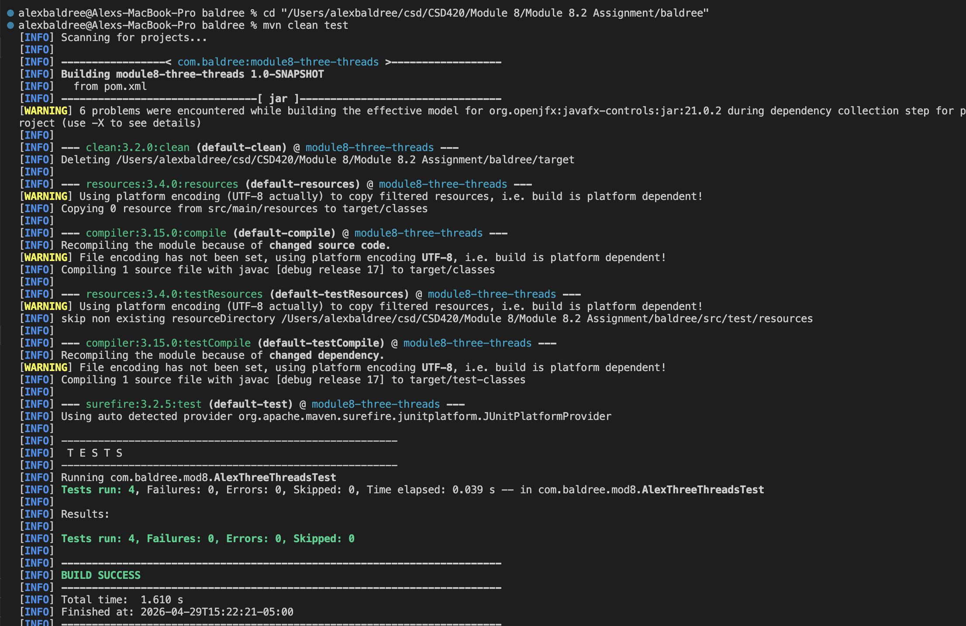
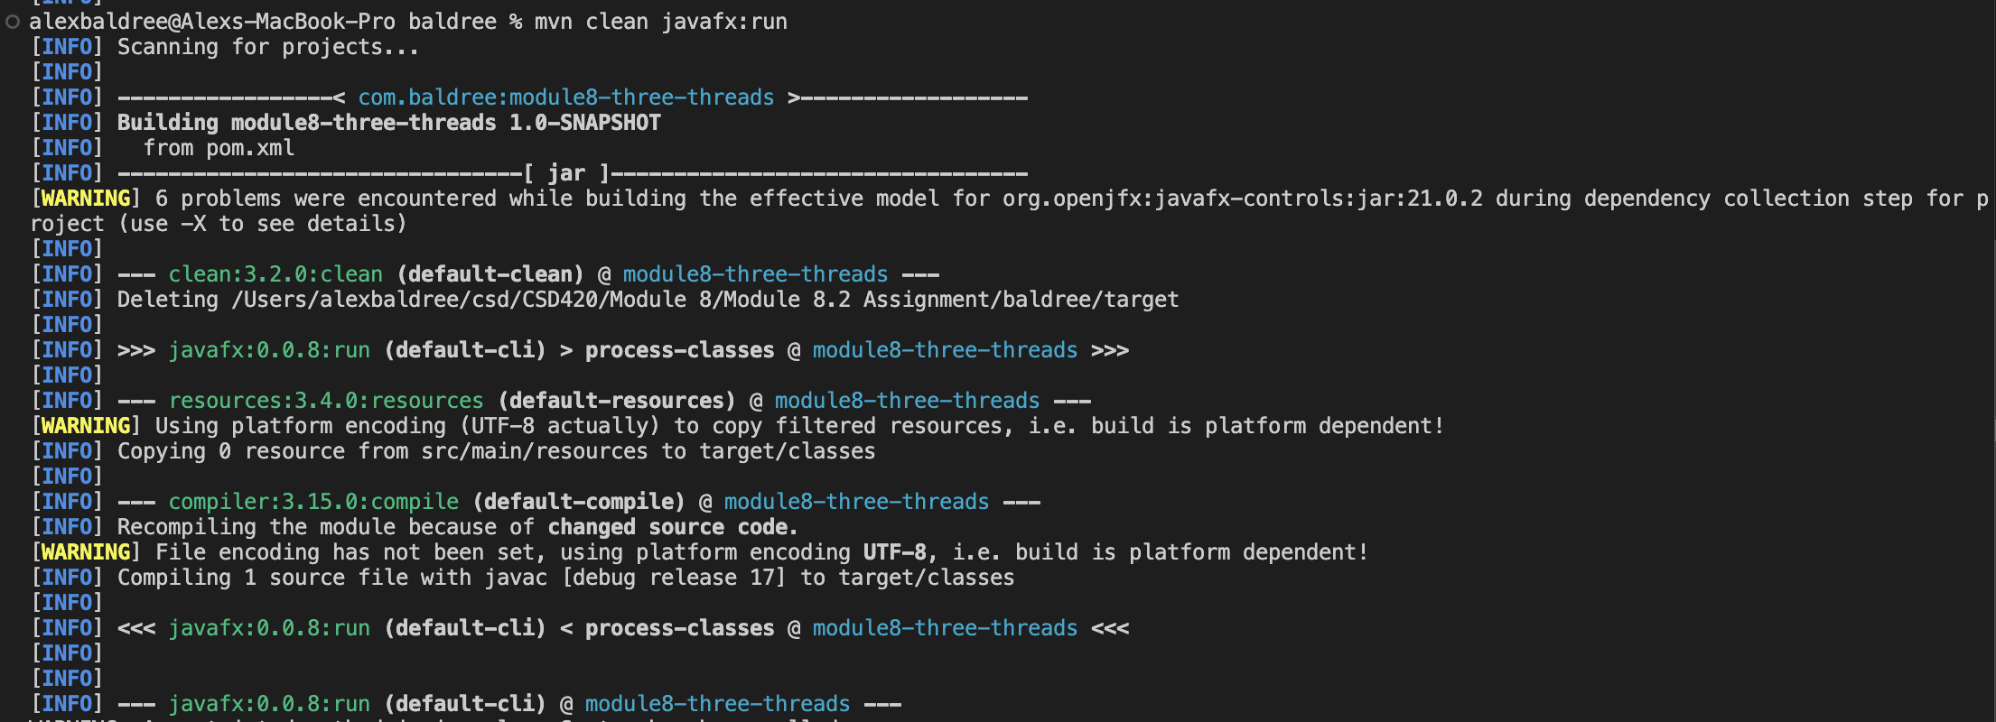

JavaFX Program Output:
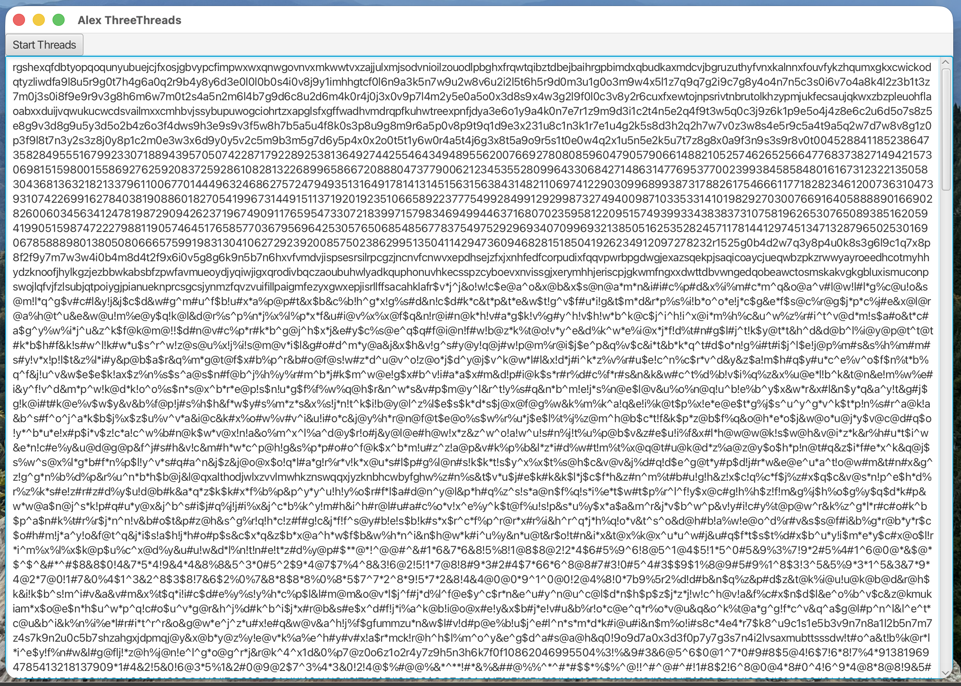

JavaFX MAVEN install:
